Chamber Executive Board Meeting
11:30-12:30
May 7 – Sentry Bank ~~~~~~~~CANCELLED

Attendees: Leslie Lane Kerry Peterson Adam Otteson Erica Jodsaas Brad Eckhoff Jude DuHoux
  - Call to Order
  - March Board Meeting Minutes
    - Motion to approve by:
    - Motion seconded by:
  - March Treasurer’s Report- (Reading & approval expenses & revenues)
    - Motion to approve by:
    - Motioned seconded by:
  - Showcase recap
    - See attached survey sheet
    - American Auxiliary membership dues
  - Marketing
    - New Website navigation and coupon idea
    - Business Card Rack (see ideas on second page)
    - BAM Update
  - (Ann Reisner)/Bad Habit/Local Blend/Kays/McDonalds/Bello/Coborns
  - Newsleaders/SJP/Church of St. Joseph
  - Estates B&B: pdf file to forward to BAM
  - Resurrection: Rootbeer Floats possibly luggage?
- Helen Marshall-Adamietz will be at the next meeting
- New Members
- Top Hatters/Ambassador Program (ribbon cutting), anniversary, remodel, open house, grand re-opening
  - Scheduled (with at least two volunteers)
  - Visit (1/2 hour)
  - Certificate (framed or not framed)
- Young Professionals of St. Joseph: A new program of the St. Joseph Area Chamber of Commerce with a goal to target young professionals (age 21-39) in the early stages of their career and offer them professional and social connections within the community as well as a forum for them to voice their opinions.
  - Good of the Chamber (Fan mail, donation requests etc.)
- Support each other at next Chamber meeting (phone time)
  - May 8 Chamber Meeting
    - Presenter: Borgert Products
    - Host: Shaklee
    - Caterer: Bello Cucina
  - June Chamber Meeting
    - Presenter: Dave Bentrud Mental Health Crisis in Policing
    - Host: CMCU Adam Otteson
    - Caterer: Gary’s Pizza
  - Adjourn
- Motion to adjourn by:
- Motion seconded by:
REVIEW OF MEMBERSHIP:
Please see attached excel document to discuss at the meeting.

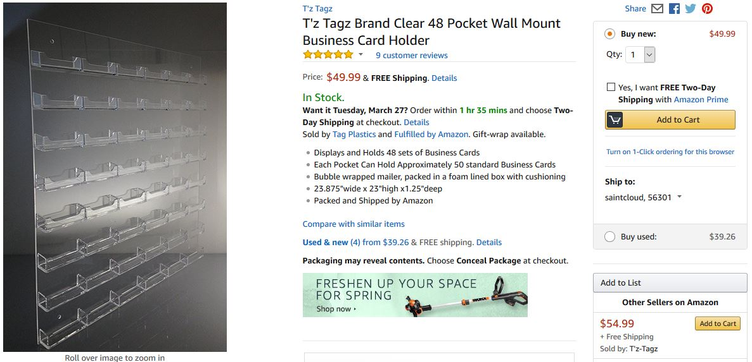

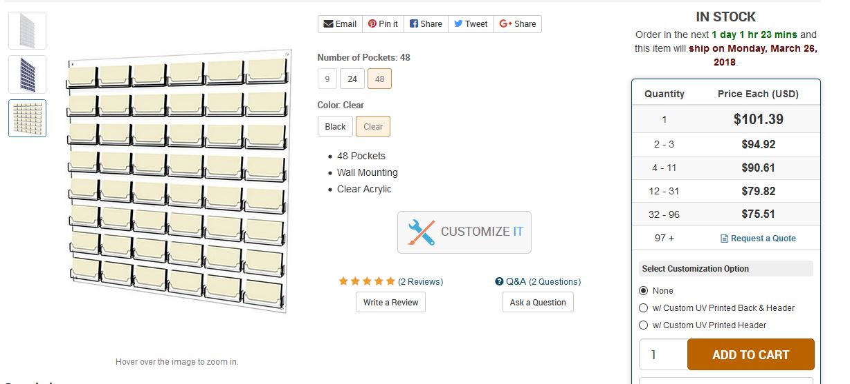

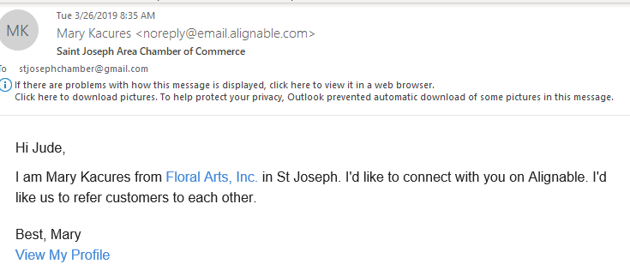

NO NEED TO READ FURTHER…THIS IS ONLY IF WE HAVE TIME

- Office Depot Update/Business Card Rack/Hot Web Deals/Constant Contact Access
1005 St. cloud members
Cold Spring Employee Recognition Program ($100 award from Chamber), winner invited to annual meeting

